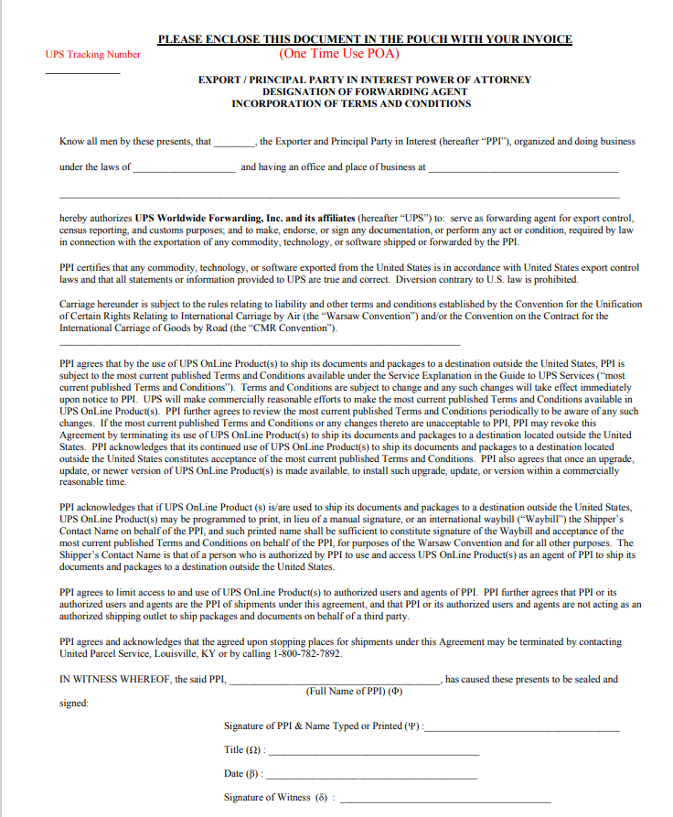

Enter company name on invoice 

Complete signature, title, and date fields. No witness signature is needed.

Insert address that matches the ship from on the invoice

Insert shipment tracking number

Insert state of ship from on the invoice

Insert company name on invoice